Media Alert
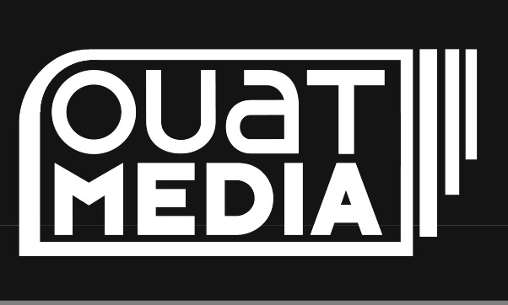
For Immediate Release
April 7, 2014

Ouat Media Releases Canadian Documentary Feature
UNCLAIMED

“A wise man once said that time heals all wounds. One thing I know for certain, that man never went to war. “
- Tom Faunce

(Toronto, Canada) – Channel Zero’s Ouat Media Inc. is proud to announce the upcoming release of UNCLAIMED (dir. Michael Jorgensen), a unique and compelling documentary about two men whose lives intersect through the burdens of war.

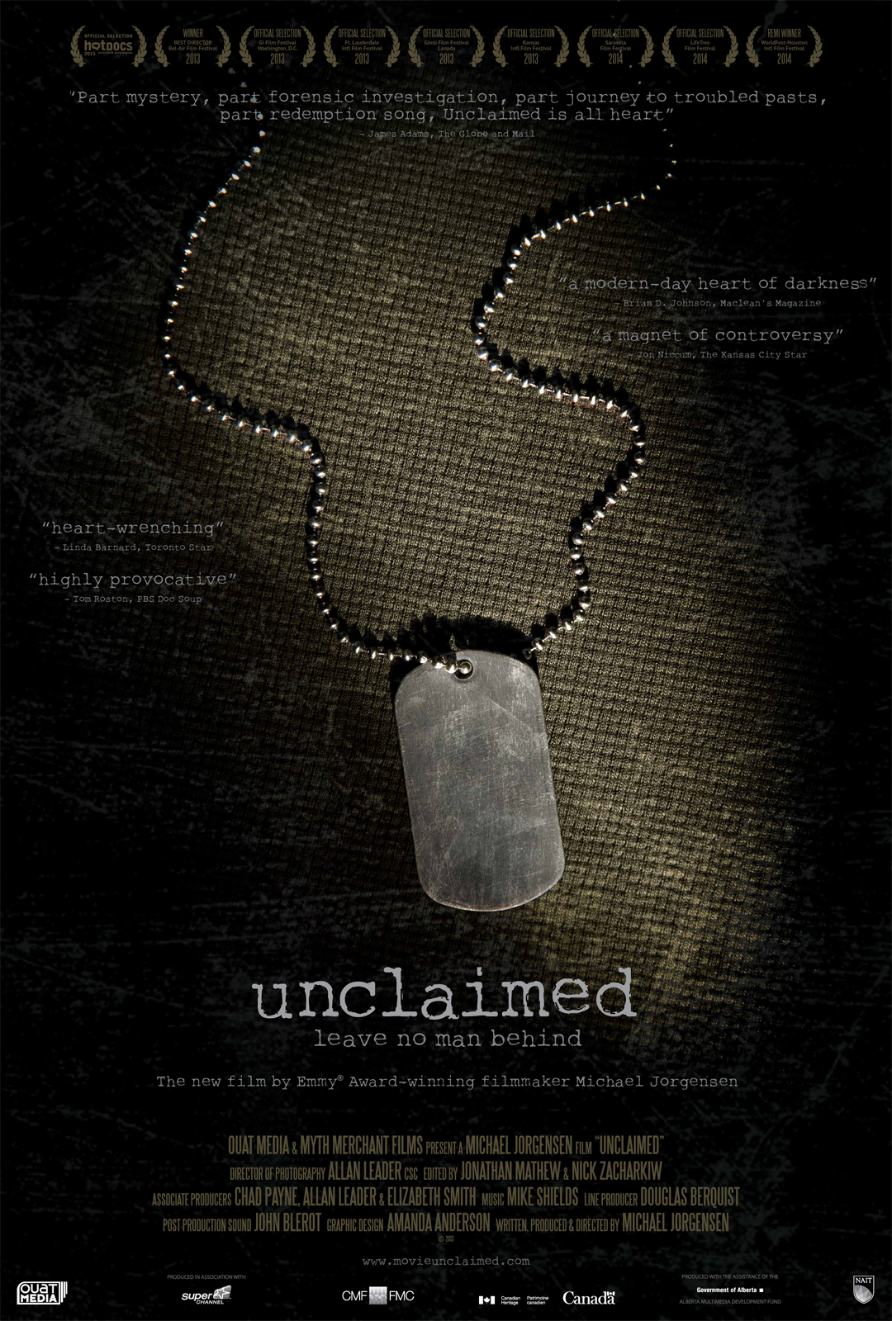

UNCLAIMED follows Tom Faunce, a war-torn Vietnam vet, in his emotional quest to uncover the true identity of a man claiming to be a Special Forces soldier living in a remote village in Vietnam, decades after being listed MIA by the U.S. Government. Directed by Emmy Award-winning Filmmaker Michael Jorgensen, UNCLAIMED premiered at the 2013 Hot Docs Canadian International Documentary Festival, and received reviews in the New York Times, Globe and Mail, Toronto Star, and Maclean’s. UNCLAIMED later made its American premiere at the GI Film Festival, and has been named an official selection of several festivals, including Kansas International Film Festival, Sarasota Film Festival and Ft. Lauderdale International Film Festival to name a few.

UNCLAIMED will be released theatrically in the United States on Friday May 2nd, 2014, and will run from May 2nd to 8th exclusively at the Quad Cinema in New York City and the Laemmle’s Music Hall Theatre in Los Angeles. For ticket and showtime information, please visit www.quadcinema.com or www.laemmle.com/theaters/4. The release of UNCLAIMED will expand to include the rest of the United States in the coming weeks, with more details to follow.

To view the trailer, please visit: https://vimeo.com/90875597.

For more information, please visit the official UNCLAIMED website: (http://movieunclaimed.com), or contact Nick Bannard (Nick.Bannard@tvchannelzero.com).

-30-

For more information, please contact:
Fred Joubaud / t: +1 416 979 7380 ext. 2112 / fred.joubaud@ouatmedia.com
www.ouatmedia.com
Facebook: www.facebook.com/ouatmediadistribution
Twitter: www.twitter.com/ouatmedia

About Ouat Media Inc.
Ouat Media [pronounced “what”] is an Academy Award® winning film sales and distribution company, providing high-profile and award-winning short form – and now feature film and television – content from the world’s top emerging filmmakers for all international platforms. Based in Toronto, Canada, Ouat Media is owned and operated by Channel Zero Inc.

About Channel Zero Inc.
Channel Zero is an independent Canadian media company that owns over-the-air channel CHCH Ontario and a growing bouquet of specialty channels including Rewind, Silver Screen Classics and Fight Now! TV – the first 24/7 combat sports channel to air in the U.S. The company is parent to Channel Zero Digital, which owns popular sites Andpop and ChartAttack, and the digital companions of its broadcast brands. Channel Zero World Media operates Bollywood Times, Mehndi TV and Halla Bol – Canada’s first South Asian HD TV channels. For more information, please visit www.tvchannelzero.com.

